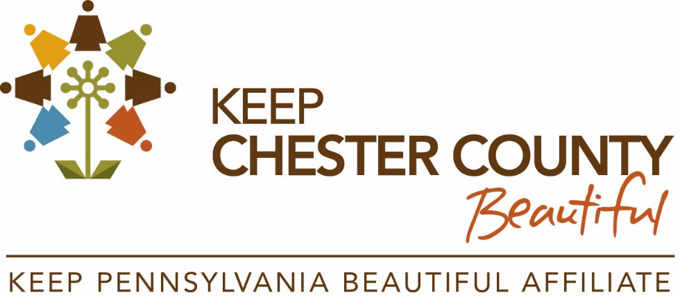

2023 Spring Giveaway - Partner Toolkit

Find Keep Chester County Beautiful on social media:
Facebook: @KeepChesterCountyBeautiful
Instagram: @KeepChesterCountyBeautiful
Twitter: @BeautifulChesco

Each spring, Keep America Beautiful hosts the "Great American Cleanup" with organizations and affiliate groups hosting events such as litter cleanups, tree plantings, restoring nature trails, and other impactful projects across the nation. In honor of the 25th anniversary of the Great American Cleanup, Keep Chester County Beautiful is hosting a Spring Giveaway to provide qualifying groups with safety vests and trash grabbers to use during their cleanup events!
SUGGESTED POSTS FOR SHARING
FACEBOOK:
Planning a community clean-up event? @KeepChesterCountyBeautiful is hosting a Spring Giveaway to provide a qualifying group with safety vests and trash grabbers to use during @KeepAmericaBeautiful’s Great American Cleanup this spring! Check out the website to learn more and enter: https://www.chescoplanning.org/Environmental/KCCB/programs.cfm
INSTAGRAM:
@KeepChesterCountyBeautiful is featuring a Spring Giveaway to provide a qualifying group with safety vests and trash grabbers to use during this year’s Great American Cleanup - the nation’s largest community improvement program taking place each spring. Check out ChescoPlanning.org to learn more and view the guidelines: https://www.chescoplanning.org/Environmental/KCCB/programs.cfm
TWITTER:
@BeautifulChesco is featuring a Spring Giveaway to provide a group with safety vests and trash grabbers to use during the Great American Cleanup this spring! Learn more and enter: https://www.chescoplanning.org/Environmental/KCCB/programs.cfm
WEBSITES, EMAIL BLASTS, NEWSLETTERS, ETC.:
The Great American Cleanup is the nation’s largest community improvement program which takes place each year through Keep America Beautiful. This spring is their 25th anniversary and to celebrate, Keep Chester County Beautiful is featuring a Spring Giveaway to provide a qualifying group with safety vests and trash grabbers to use during their event!
Visit https://www.chescoplanning.org/Environmental/KCCB/programs.cfm to learn more.

